Documentation for Data Points

1. Heart Rate:- The points for heart rates are given below

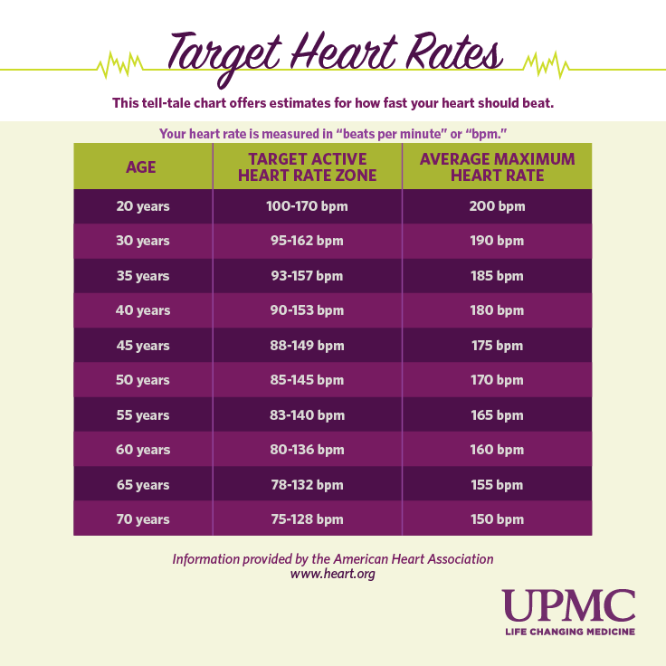

Focus on Heart Rate Variability(HRV):-

* What is HRV?

HRV is simply a measure of the variation in time between each heartbeat. This variation is controlled by a primitive part of the nervous system called the autonomic nervous system (ANS). It works regardless of our desire and regulates, among other things, our heart rate, blood pressure, breathing, and digestion.

* Use Of HRV

HRV is an interesting and noninvasive way to identify these ANS imbalances. If a person’s system is in more of a fight-or-flight mode, the variation between subsequent heartbeats is low. If one is in a more relaxed state, the variation between beats is high.

* How to Get HRV

Time-domain indices of HRV quantify the amount of variability in measurements of the interbeat interval , which is the time period between successive heartbeats .

RECOMMENDATION:- Kindly use the EliteHRV app

Also consider using AliveCor

<https://elitehrv.com/>

* Standard value table for reference:-

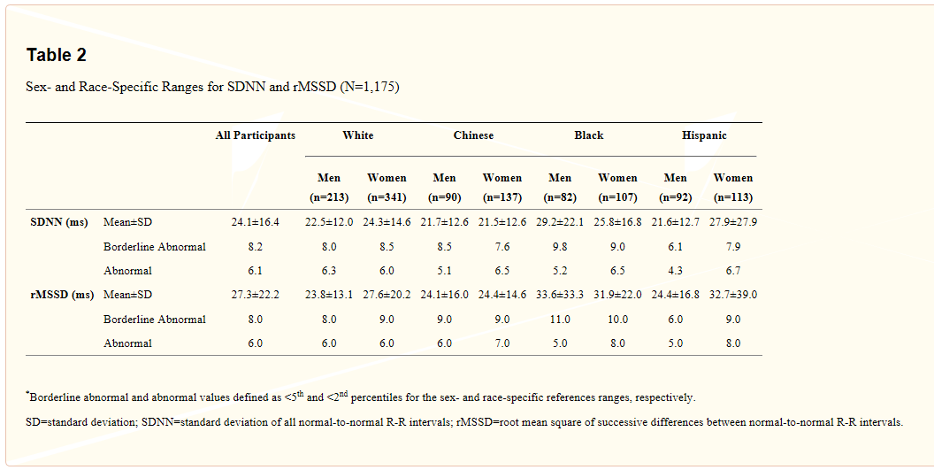

1. Accelerometer and gyroscope:-

* Kindly find the method to employ and detect rapid gesture

<https://lembergsolutions.com/blog/motion-gesture-detection-using-tensorflow-android>

1. Breathing Analysis:- To do this there are several ways, but most of them are not feasible for old Alzheimer’s patients as they are uncomfortable to wear and need constant adjusting. The best way found was to use BioHarness which is a wearable tech only like others but, the design makes it comfortable for the patient and it will not require fine adjustments.
2. To sense pressure in the fist, we can attach multiple force sensing sensors on a glove. Whenever the force goes beyond a certain threshold we can say that pressure is being applied.